CENWP-OD-B 09/11/12

MEMORANDUM FOR THE RECORD

SUBJECT: 12BON33 Chinook mortality at Bonneville’s Adult Fish Facility (AFF)

On 11 September at 1328 hours, CRITFC researchers contacted Project Fisheries to report a dead adult fall chinook in the AFF. The fish was processed in the anesthetic tank and returned to the brail pool, but did not recover. Researchers monitored the fish over several hours but no improvement was noted. The mort was released to the Valve 15 return pool drain. Information collected is provided below:
- Species – Fall Chinook male
- Origin – No adipose clip
- Length – 80.0 cm
- Marks and tags – PIT tagged, 3D9.1C2DE21944
- Marks and Injuries found on carcass – Approx. 7 cm diameter enlarged cyst present on side. Portion of upper lip absent.
- Cause and Time of Death – Stress induced from sampling/handling at approx. 1000 hours on 11 September.
- Future and Preventative Measures – Not applicable at this time.
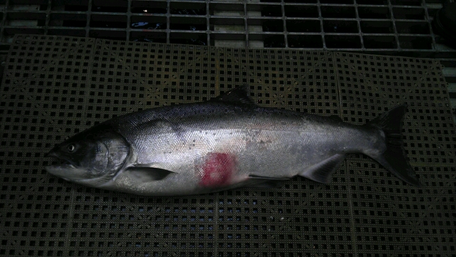
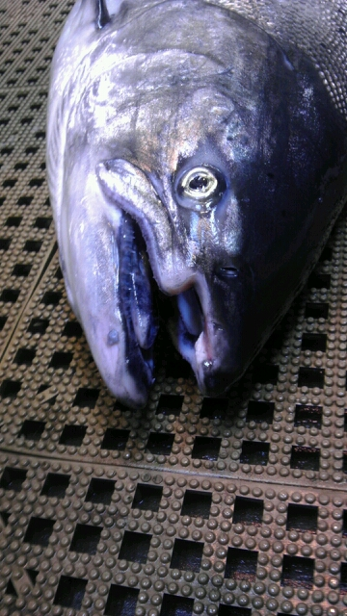

Sincerely,
Bonneville Project Fisheries

